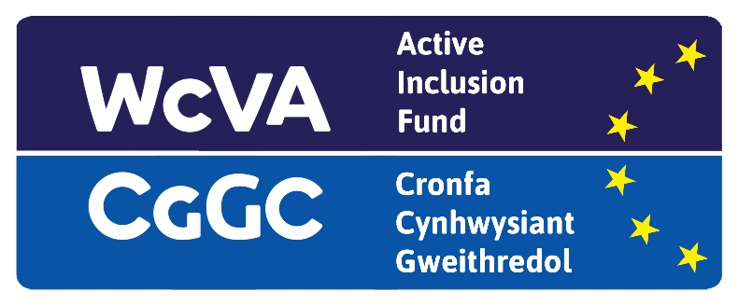

EYST Wales/ Tiger Bay Boxing Club

BME Youth Invest Work Placement (Cardiff)

Job Description

Job Title: Administration Assistant
Hours of Work: 16 hours per week (For 16 Weeks)
Location: Tiger Bay Boxing club, Bute Street, Cardiff
Salary: National Minimum Wage – age appropriate

Aims of the post
The Administration Assistant will support the manager in the office with general office duties.

Key Responsibilities

- Supporting with day-to-day office administration work
- Working from our database to organize and tidy files online
- Respond to enquiries by phone, by email and in person
- Updating website, social media and using MS Office (Word, Excel and PowerPoint)
- Maintaining and updating database records regarding membership
- Process applications and payments of new and current members
- Assist with supervision of gym facilities
- Maintain and ensure cleanliness of gym facility and equipment
- Coordinate boxing schedule and training session.

Person Specification

- Excellent written and verbal communication skills
- Excellent organisational and administrative skills with the ability to work to tight deadlines
- Ability to deal confidently with telephone enquiries from service users and other individuals
- The ability to work effectively as part of a team - able to work with others, communicate effectively to achieve goals, provide help and assistance and share information with other team members
- Be self-motivating and able to work on your own
- Show initiative - take personal responsibility for getting things done, asking for advice when necessary
- Develop ideas for improving the way tasks are done and take improvements forward
- Manage time effectively - plan work to manage a number of tasks and be resourceful, with a flexible approach
- Committed to excellence in client care
- Be positive about working in a changing and challenging environment
- Respect confidentiality and data protection
- Make effective use of technology and use resources responsibly

