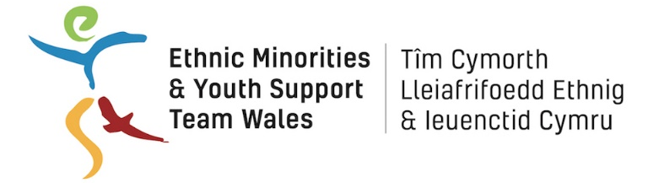
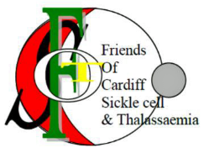

JOB DESCRIPTION

Post Title

Children’s Sickle Cell and Thalassemia Project Coordinator

HOURS: 8 hours per week (flexible to include evenings and weekends)

REPORTING TO: EYST Chief Executive

SALARY: £5028 per annum (equivalent to £22,000 per annum pro rata)
Tenure: Fixed term for 2 years
Responsible for: Sessional Workers

Main purpose of the Post:

This project aims to support children who are affected by Sickle Cell or Thalassemia* living in Wales. Those affected (children who have a sickle cell disorder or a thalassaemia disorder, the child siblings of children who have a sickle cell disorder or a thalassaemia disorder and children who do not have a sickle cell or thalassaemia disorder but are children of adults who do) number about 50. They live in most areas of Wales but in the South Wales cities in particular.

The post holder will be based within EYST offices in Butetown, Cardiff and will develop and deliver the Children’s Sickle Cell and Thalassemia project, providing support, advice and activities for children up to 18 years in Wales. Supported by a Sessional Worker, the post holder will deliver 2 monthly Saturday Clubs or equivalent activities for children and their families, 1 club for children aged 0-10 years and one for children aged 11-18 years.

The post holder reports to the EYST Chief Executive but will be expected to work on own initiative. They will work closely with the project’s steering body that includes EYST, the Friends of Cardiff Sickle Cell & Thalassaemia, Cardiff and Vale University Health Board, Diverse Cymru the other partners in terms of consistent work practices, mutual support, and sharing of information/good practice on support work.

Main Duties:
- To take the lead in developing and delivering the SCT project according to the project plan
- To identify the support needs of children affected by Sickle Cell and thalassemia* across Wales.
- To develop and deliver appropriate and engaging regular centre-based activities for 2 groups of children affected by SCT– ages 0-10yrs and 11 – 18yrs.
- To develop and deliver appropriate and engaging regular external activities for children. This may involve participation in activities organised by other agencies such as the Sickle Cell Society and the UK Thalassaemia Society.
- Supervision of the Sessional Worker supporting the Saturday Clubs.
- Maintain paper/computerised records containing client’s personal information, in accordance with relevant GDPR requirements.
- To ensure the safeguarding of all children using the project in accordance with national guidelines and EYST policies.
- To develop and maintain relevant contacts and relationships, primarily in the statutory and voluntary sectors.
- To monitor the work of the project and provide written reports as required.
- To undertake any other duties as required which are appropriate to the work of the project and which are commensurate with the responsibility levels of the post, and bearing in mind the developing nature of the service.
- To maintain a high-level quality service maintaining standards throughout
- Managing a budget
- General responsibility for all equipment.

Personal Specification

- Willing to, and commitment to, undertake training as required, specifically in relation to SCT.
- An understanding of the needs of black and minority ethnic (BME) communities and their diversity.
- An understanding of health inequalities relating to BME communities and specifically Sickle Cell and Thalassemia and their impact upon children, family and community
- Ability to line manage sessional workers and supervise volunteers
- Excellent inter-personal skills, able to work with possible conflict and challenges using tact and diplomacy.
- An understanding of and commitment to equality and diversity issues.
- Experience of working with children or young people
- Able to work flexible hours i.e. outside of 9-5
- The ability to communicate fluently and in a relevant community language (desirable)
- Good written and verbal communication and presentation skills.
- Ability to work sensitively with individuals (some of whom have complex social and health needs), groups and organisations.
- Ability to prioritise and manage own work load.
- Competency in IT (using Microsoft Office),
- Must be legally entitled to work in the UK.
- Car own Driver
- Enhanced DBS check will be required

