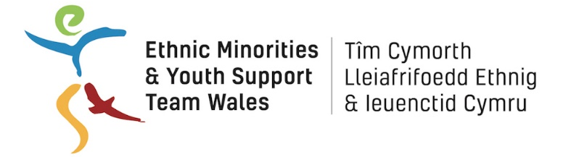
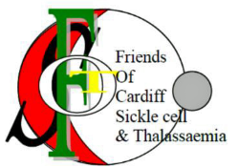

JOB DESCRIPTION

Post Title

Children’s Sickle Cell and Thalassemia Project Coordinator

HOURS: 8 hours per week (flexible to include evenings and weekends)

REPORTING TO: EYST Chief Executive

SALARY: £5028 per annum (equivalent to £22,000 per annum pro rata)
Tenure: Fixed term for 2 years

PRIME OBJECTIVES OF THE POST:

This project aims to support children who are affected by Sickle Cell or Thalassemia* living in Wales. *Children who have a sickle cell disorder or a thalassaemia disorder, the child siblings of children who have a sickle cell disorder or a thalassaemia disorder and children who do not have a sickle cell or thalassaemia disorder but are children of adults who do.

The post holder will be based within EYST offices in Butetown and will develop and deliver the Children’s Sickle Cell and Thalassemia project, providing support, advice and activities for children up to 18 years in Wales. Supported by a Sessional Worker, the post holder will deliver 2 monthly Saturday Clubs for children and their families, 1 club for children aged 0-10 years and one for children aged 11-18 years.

The post holder will provide advice to children and their families on services and benefit entitlements; this will include home visits and one to one support.

SUPERVISORY RESPONSIBILITIES:

- Supervision of Sessional Worker.

SUPERVISION AND GUIDANCE:

- Reports to the EYST Chief Executive but will be expected to work on own initiative.
- Will work closely with the project’s steering body that includes EYST, the Friends of Cardiff Sickle Cell & Thalassaemia, Cardiff and Vale University Health Board, Diverse Cymru the other partners in terms of consistent work practices, mutual support, and sharing of information/good practice on support work.

RANGE OF DECISION MAKING:

- Will be required to exercise a high degree of professional judgement, consistency and objectivity in relation to providing support and information to clients.
- Will be expected to determine and analyse outcomes of the support service.

RESPONSIBILITY FOR ASSETS, MATERIALS ETC:

- Responsible for data collected in pursuit of the above objectives.
- Access to paper/computerised records containing client’s personal information, in accordance with relevant GDPR requirements.
- General responsibility for all equipment.

CONTACTS:

Operational contact with:
- Service users and families/carers – children across Wales (primarily south, mid and west Wales)
- Local Health Boards across Wales
- Agencies involved in related information and support services

RANGE OF DUTIES:
- To identify the support needs of children affected by Sickle Cell and thalassemia* across Wales.
- To develop and deliver appropriate and engaging regular centre-based activities for 2 groups of children, and their families – ages 0-10 and 11 – 18.
- To develop and deliver appropriate and engaging regular external activities for children and their families.
- To provide advice, information and assistance to children and their families around DLA applications and other benefit entitlements
- Supervision of the Sessional Worker supporting the Saturday Clubs.
- To develop systems to signpost children and their families to relevant organisations when necessary.
- Keeping clear and precise records for all clients and be aware of confidentiality policies and safeguarding procedures.
- To ensure the safeguarding of all children and families using the project in accordance with national guidelines and EYST policies.
- To develop and maintain relevant contacts, primarily in the statutory and voluntary sectors.
- To monitor the work of the project and provide written reports as required.
- To undertake any other duties as required which are appropriate to the work of the project and which are commensurate with the responsibility levels of the post, and bearing in mind the developing nature of the service.
- To maintain a high-level quality service maintaining standards throughout
- Managing a budget

PERSONAL SPECIFICATION

POST TITLE: Project Coordinator POST REF: SCT1

SUMMARY OF JOB:
- The post holder will develop and deliver the Children’s Sickle Cell and Thalassemia support project

ATTRIBUTE |  | ESSENTIAL CRITERIA | DESIRABLE CRITERIA | HOW IDENTIFIED
QUALIFICATIONS |  | - Educated to GCSE, Welsh Baccalaureate or equivalent level | Educated to degree level | Application form and Selection Process. Certificates
EDUCATION / TRAINING |  | - Willing to, and commitment to, undertake training as required. Willing to receive additional training required to achieve a proper understanding of the natures of sickle cell disorders and thalassaemia disorders in order to communicate fully with families and health service providers alike and to properly risk assess any proposed activities. | Evidence of personal development in the last two years.  Recent training in engaging with diverse communities  Youth Work qualification. Knowledge of the special needs of children affected by sickle cell or thalassaemia disorders*. | Application form & Selection Process.
KNOWLEDGE / EXPERIENCE |  | - An understanding of the needs of black and minority ethnic (BME) communities and their diversity.  - An understanding of health inequalities relating to BME communities.  - An understanding of equality and diversity issues.  - Experience of working with children e.g. Youth work | Experience of supervising and training sessional workers and volunteers  Experience of working with interpreters | Application form & Selection process
CIRCUMSTANCES/  PERSONAL |  | - Must be legally entitled to work in the UK.  - The ability to drive and with access to licensed vehicle and appropriately insured (e.g. business use)  - Able to work flexible hours i.e. outside of 9-5  - No contra indications in personal background or criminal record indicating unsuitability to work with children/young people/vulnerable clients (DBS check will be required)  - Willing to travel in the UK | The ability to communicate fluently and in a relevant community language | Sight of appropriate documentation as specified in interview letter  Selection process
PRACTICAL AND  INTELLECTUAL SKILLS |  | - Good written and verbal communication and presentation skills.  - The ability to communicate well and work sensitively with individuals (some of whom have complex social and health needs), groups and organisations.  - The ability to set priorities and work to them while remaining responsive to events.  - Competency in ICT (using Microsoft Office), including the ability to use a database.  - Must be able to perform all duties and tasks with reasonable adjustment, where appropriate, in accordance with the Equality Act 2010 |  | Application form & Selection process  Selection process.
SPECIALIST KNOWLEDGE |  | - Ability and commitment to maintaining confidentiality of information relating to the organisation  - Knowledge of support needs and their impact upon children, family and community |  | Application form & Selection process
DISPOSITION/ ADJUSTMENT/  ATTITUDE |  | - The ability to show initiative and take direction.  - Ability to motivate and inspire volunteers  - Excellent inter-personal skills, able to work with possible conflict and challenges using tact and diplomacy.  - Ability to work as part of a team  - Candidates should indicate an acceptance of and commitment to the principles underlying Equal Rights and Diversity policies and practices. |  | Selection process

