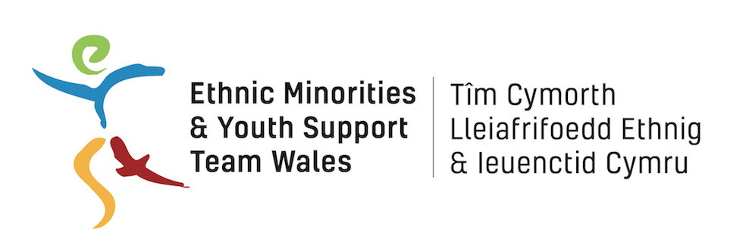

Resilience Project

Project Education Resources Officer

Job Description

Job Title: Project Education Resource Officer

Hours of Work: Full –time 35 hours per week – fixed term for 6 months

Salary: £22,000 per annum

Responsible to: Resilience Project Coordinator

Responsible for:

Aims of the Post
- To contribute to the delivery of the Resilience Project, addressing and reducing the vulnerability of young people to Islamist and far-right extremism and sexual exploitation.
- To design and produce effective training resources addressing the three project themes of Islamist Extremism, Far Right Extremism and Sexual Exploitation.
- To support the marketing and dissemination of the project training offer.

Principal Accountabilities and Main Duties
- To research and design effective training material to aid project delivery,
- To produce a series of training courses of varying lengths addressing the addressing three project themes of Islamist Extremism, Far Right Extremism and Sexual Exploitation.
- To produce training packs for a range of audiences including professionals and young people.
- To research and register for appropriate accreditation options for the training courses
- To complete the training packs within required time-scales
- To take part in training courses, staff meetings and regular supervision
- To work within relevant health and safety legislation
- To ensure that the project promotes and reflects equality of opportunity at all levels
- To ensure that EYST Safeguarding and all other relevant policies are implemented
- To uphold the confidentiality of information of clients
- To ensure EYST administrative and financial systems are effectively maintained
- To work with the rest of the Resilience Project Staff to set and maintain a culture of high professional standards and to deliver best value services
- To carry out any other duties that may from time to time be required

Person Specification
- Experience in a similar role –education or training design or delivery.
- Experience of producing training resources for different audiences including young people and professionals.
- Experience of working with BME young people and understanding of their needs.
- A commitment to working with disengaged or vulnerable groups
- Good interpersonal and customer service skills
- Experience of working with statutory and voluntary organisations
- Advanced skills in IT, including Email, Word, Excel, Powerpoint, Internet
- Confident in social media use
- Ability to organise own work-load, take initiative and work with minimum supervision
- Educated to Degree level
- Personal commitment to Social Justice, Equality, Inclusivity and Human Rights
- Passion for and commitment to making a positive difference

