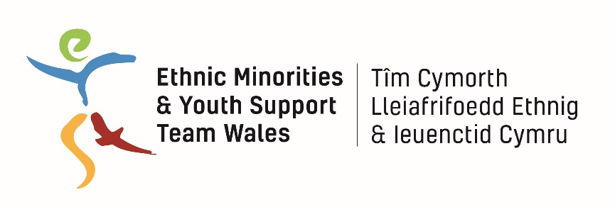

Resilience Project

Female* Project Worker

Job Description

Job Title: Female* Project Worker (CSE)

*This is a genuine occupational requirement under the Equality Act 2010

Hours of Work: Part-time 21 hours per week

Salary: £12,600-£14,400 per annum (£21,000 - £24,000 pro rata – depending on experience)

Responsible to: Resilience Project Coordinator

Responsible for: Peer Mentor Volunteers; Project participants

Aims of the Post
- To support the delivery of the Resilience Project in Swansea, addressing and reducing the vulnerability of young people to Islamist and far-right extremism and sexual exploitation.
- To engage and work directly with a case load of young people, including BME young people who may be vulnerable to sexual exploitation, through one-to-one support and group work.
- To deliver a programme of educational workshops appropriate to the needs of BME and vulnerable young people who may be vulnerable to sexual exploitation
- To work effectively in partnership with referring and partner organisations to meet the aims of the project

Principal Accountabilities and Main Duties

- To work effectively as part of the Project Team to deliver the project according to the project plan
- To engage with young people who may be vulnerable to sexual exploitation via schools-based and community outreach and via Youth Drop-In Sessions
- To support a caseload of young clients via regular support sessions, providing advice, guidance, mentoring, signposting and referral as required.
- To lead on the planning, organisation and delivery of a programme of workshops aimed at vulnerable young people who may be vulnerable to sexual exploitation
- To develop and maintain effective working relationships with partner agencies and liaise effectively with these on a range of subjects, including referrals, agency input into the programme, resource sharing, etc.
- To represent the project at local networks, events and meetings when required
- To facilitate effective feedback and consultation mechanisms for young people to contribute to project development
- To present regular progress reports as required
- To ensure the collection, entry and return of information as required for monitoring and evaluation
- To take part in training courses, staff meetings and regular supervision
- To work within relevant health and safety legislation
- To ensure that the project promotes and reflects equality of opportunity at all levels
- To ensure that EYST Safeguarding & Child Protection and all other relevant policies are implemented
- To uphold the confidentiality of information of clients
- To ensure EYST administrative and financial systems are effectively maintained
- To work with the EYST Director and Management Committee to set and maintain a culture of high professional standards and to deliver best value services
- To carry out any other duties that may from time to time be required

Person Specification

Essential

- A minimum of two years’ experience of working with vulnerable and BME young people in a relevant setting, e.g. detached or centre based youth work
- In-depth knowledge and experience around the issues of sexual exploitation as they affect BME and vulnerable young people.
- Proven ability to engage with, enthuse and mentor BME and vulnerable young people
- Experience of delivering one-to-one work to vulnerable and BME young people
- Experience of delivering educational workshops to young people
- Experience of working with a range of statutory and voluntary organisations, specifically within the criminal justice system, youth sector and alternative education providers.
- Knowledge and understanding of issues affecting young people and experience of involving them in educational programmes
- Awareness of Safeguarding and Child Protection Issues
- An understanding and commitment to equal opportunities
- Excellent communication and interpersonal skills
- Competence in IT, including Email, Word
- A flexible and positive approach to working as part of a team.
Desirable

- A Car Owner/Driver
- A Youth Work or Teaching Qualification

