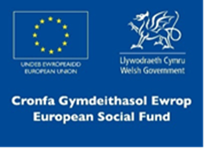
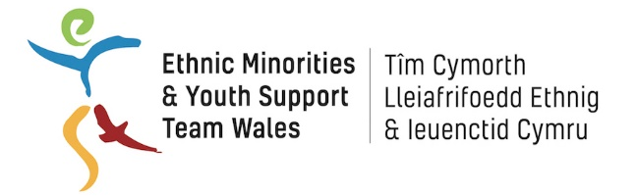
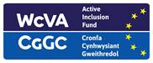

EYST Wales

BME (Youth) Invest Work Placement

Job Description

Job Title: Project Admin Officer (Level 1) – Work Placement

Hours of Work: Part-time 16 hours per week

Salary: National Minimum Wage

Tenure: Fixed term for 16 weeks

Responsible to: GROW Cymru staff

Aims of the Post
- To provide effective administrative support to GROW Cymru staff
- To market and promote the work of GROW Cymru via leaflets and posters for the intended target groups

Principal Accountabilities and Main Duties

Specific
- To work under the guidance of GROW Cymru staff to provide effective administrative support to the organisation
- To design and produce effective marketing flyers, posters and logos for diverse target audiences to promote and support the work of GROW Cymru projects
- To answer calls, emails and respond to enquiries regarding the work of GROW Cymru

General
- To ensure regular reporting and updates to partners as required.
- To ensure the collection, entry and return of information as required for monitoring and evaluation
- To take part in training courses, staff meetings and regular supervision
- To work within relevant health and safety legislation
- To ensure that the project promotes and reflects equality of opportunity at all levels
- To ensure that EYST Child Safeguarding and all other relevant policies are implemented
- To uphold the confidentiality of information of clients
- To work with the wider EYST team to set and maintain a culture of high professional standards and to deliver best value services
- To carry out any other duties that may from time to time be required

Person Specification

- Aged 18+ currently not in education, employment or training (or economically inactive/long-term unemployed)
- Ability to speak English is essential
- Good interpersonal and customer service skills
- Knowledge of Child Safeguarding issues
- Good communication skills and a professional manner
- An understanding and commitment to equal opportunities
- Ability to use social media including Facebook, Instagram and Twitter
- Competence in IT, including Email, Word, Powerpoint and the Internet
- Organised, focussed and self-motivated

Please note

We welcome applications from female applicants from a BME background who are currently not in education, employment or training or who are long term unemployed or economically inactive.

Applications for this vacancy are by online application form only, CVs are not accepted.

All application forms are to be received by EYST Wales before 5pm on Friday 20th March.

Interviews for this post will be held on Tuesday 24th March.

This Active Inclusion vacancy is funded by ESF (European) funds managed by WCVA.

The work placement is organised by EYST Wales and hosted by GROW Cymru.

