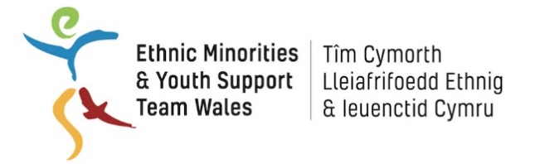
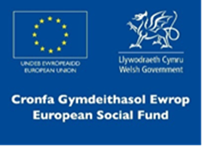

EYST Wales

BME Youth Invest Work Placement

Job Description

Job Title: FAW Trust Community Coordinator – Work Placement

Area: South Cardiff, probably Grangetown

Hours of Work: Part-time 16 hours per week (days/evenings; flexibility required - dependant on programme delivery

Salary: National Minimum Wage (age appropriate)

Tenure: Fixed term for 16 weeks

Responsible to: FAW Trust Football Development Manager

Purpose of the Role
For more than 20 years, it's been our job at the Football Association of Wales Trust (FAWT) to work with the Football Association of Wales (FAW) to protect, promote and develop the game of football to achieve our joint vision of football for everyone, everywhere in Wales.

As one of our Community Coordinators, you'll support the FAWT to connect with members of the local community to promote the benefits of football for all age groups and abilities. You might work with schools, sports teams, community groups or individuals; empowering them to become Champions of their community and to create, develop and deliver football activity that is accessible to all regardless of gender, background or ability.

The FAW Trust will support you in this role and provide all the necessary training and resources required.

Aims of the Post

- With the support of the Football Development Manager, consult with the local community to identify the gaps in football provision
- Develop and implement the relevant programmes based on the gap analysis
- Assist with the recruitment of volunteers who can continue to deliver football provision

Principal Accountabilities and Main Duties

Specific
- To work under the guidance of the Football Development Manager to provide general administrative support to the organisation
- Ensure local people have their say and highlight any issues or barriers to participation and suggest appropriate solutions
- Act as a link between communities and a range of other local authority and voluntary sector providers

General
- To ensure the collection, entry and return of information as required for monitoring and evaluation
- To complete necessary training as indicated by the FAW Trust
- To take part in meetings and regular supervision
- To work within relevant health and safety legislation
- To ensure that the project promotes and reflects equality of opportunity at all levels
- To ensure that EYST Child Safeguarding and all other relevant policies are implemented
- To uphold the confidentiality of information of clients
- To work with the wider EYST team to set and maintain a culture of high professional standards and to deliver best value services
- To carry out any other duties that may from time to time be required

Person Specification

Essential requirements
- Aged 18-24 and from a BME background; currently not in education, employment or training
- Excellent communication and interpersonal skills
- Good listening skills
- Highly motivated and works to own initiative
- Creative thinking and problem-solving ability
- Modern IT competencies
- Willingness to work flexibly and unsociable hours
- Enhanced DBS certificate (can be arranged through EYST)

Desirable requirements
- Full, clean driving licence
- Knowledge and understanding of the Grangetown and Butetown communities
- Experience and understanding of working with young children

Please note
Applications for this vacancy are by online application form only, CVs are not accepted.

All application forms are to be received by EYST Wales before 5pm on Friday 6th March.

Interviews for this post will be held on Tuesday 10th March.

This vacancy is funded by ESF (European) funds managed by WCVA.
The work placement is organised by EYST Wales and hosted by the Football Association of Wales Trust.

