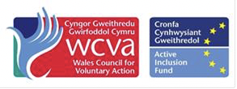
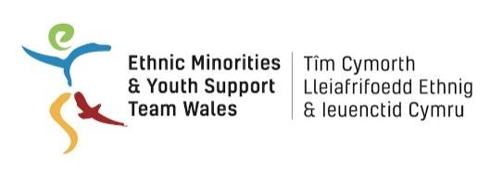
/

EYST Wales/ Cardiff Third Sector Council

BME Youth Invest Work Placement

Job Description

Job Title: Admin Assistant

Hours of Work: 16 hours per week

Location: Baltic House, Mount Stuart Square, Cardiff

Salary: National Minimum Wage – age appropriate

Responsible to: Volunteer Manager

Aims of the post

The Administration Assistant will support a friendly team in the Cardiff Third Sector Council's office in Cardiff Bay. General duties include: working from our database to organize and tidy files, contacting organizations to ensure their documentation is up-to-date as per requirement, supporting with day-to-day office administration work including answering the telephone, emails and updating our membership spreadsheet. Desirable Skills: IT, Social Media, communication and planning skills are needed and an ability to prioritise and work well within a team.

Key responsibilities:

- Respond to enquirers from different sectors and diverse backgrounds by phone, by email and in person, signposting to other organisations when appropriate
- Process membership applications and renewals; update directories and databases
- Run mailings and mail-merges when necessary
- Process applications, maintaining and updating records.
- You will work alongside the Office Administrator who will support you with the office based tasks to provide guidance and support when needed.
- Assist the administrator with task as per requirement.
- Carry out further duties appropriate to the post in furtherance of Cardiff Third Sector Council’s stated purpose.
- Updating website, social media and using MS Office (Word, Excel and PowerPoint)

Person specification

- Excellent written and verbal communication skills
- Excellent organisational and administrative skills with the ability to work to tight deadlines
- Proven ability to deal confidently with telephone enquiries from service users and other individuals and agencies from diverse backgrounds
- Commitment to equality and diversity is essential
- The ability to work effectively as part of a team - able to work with others, communicate effectively to achieve goals, provide help and assistance and share information with other team members
- Be self-motivating and able to work on your own
- Show initiative - take personal responsibility for getting things done, asking for advice when necessary
- Develop ideas for improving the way tasks are done and take improvements forward
- Manage time effectively - plan work to manage a number of tasks and be resourceful, with a flexible approach
- Committed to excellence in client care
- Be positive about working in a changing and challenging environment
- Respect confidentiality and data protection
- Make effective use of technology and use resources responsibly

