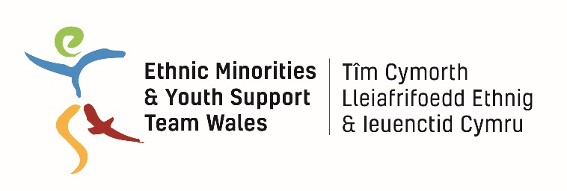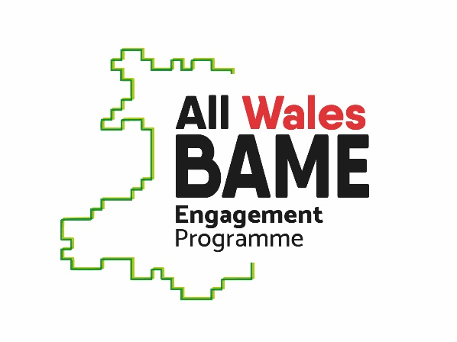

EYST Wales is building evidence on:
Experiences of BAME (Black, Asian and Ethnic Minority) Graduates in Wales’ Labour Market

BAME young people are achieving more than ever in further education and higher education. We want to better understand if those achievements are translating into success in the jobs market in Wales or if BAME graduates face additional barriers when entering the jobs market after completing further or higher education.

If you are an ethnic minority person who has completed higher or further education within the past five years (or will graduate within the next year), we would appreciate talking to you about your experiences in the labour market. You could attend one of the following focus groups:
- Cardiff: 23rd July, 5:30-7pm, EYST Office, Butetown, S Loudoun Place
- Swansea: 25th July, 6-7:30pm, EYST Drop-in, Swansea, 11 St Helens Rd
- Newport: 30th July, 5:30-7pm, location TBA

We hope to speak with graduates from multiple sectors and disciplines. We welcome hearing from people with a wide range of different experiences in the labour market, both bad and good. We hope to identify any barriers to employment for BAME graduates such as discrimination, but also want to highlight good outcomes, success stories and best practices.

We will use this information to write a short evidence paper which will be publicly available and shared with Welsh Government, public sector bodies and voluntary organisations. This paper will be used to influence Welsh Government and Higher Education institutions to create positive changes in policy and practice.

To register for one of the focus groups, contact Chizi at chisomo@eyst.org.uk or text 07939 429393.

Also contact Chizi If you can’t attend a focus group, but would still like to share your thoughts. We can arrange a meeting or phone/skype conversation.

